Slide Scanning Tray Info:

Trays hold up to 20 standard sized microscope slides and fit on standard flatbed scanners similar to the Epson V500.

Tray may be oriented on the scanner in either direction, but pegs face up and slides are placed face down onto the tray.

You may close scanner lid over trays if model allows.

Place lot label identifiers, color cards, etc. in the empty space on the far right of the tray as shown on the template below.

Cleaning: Use only a mild soap detergent with water and a cloth rag to clean trays. Alcohol can be harmful to the Plexiglas and cause cracks.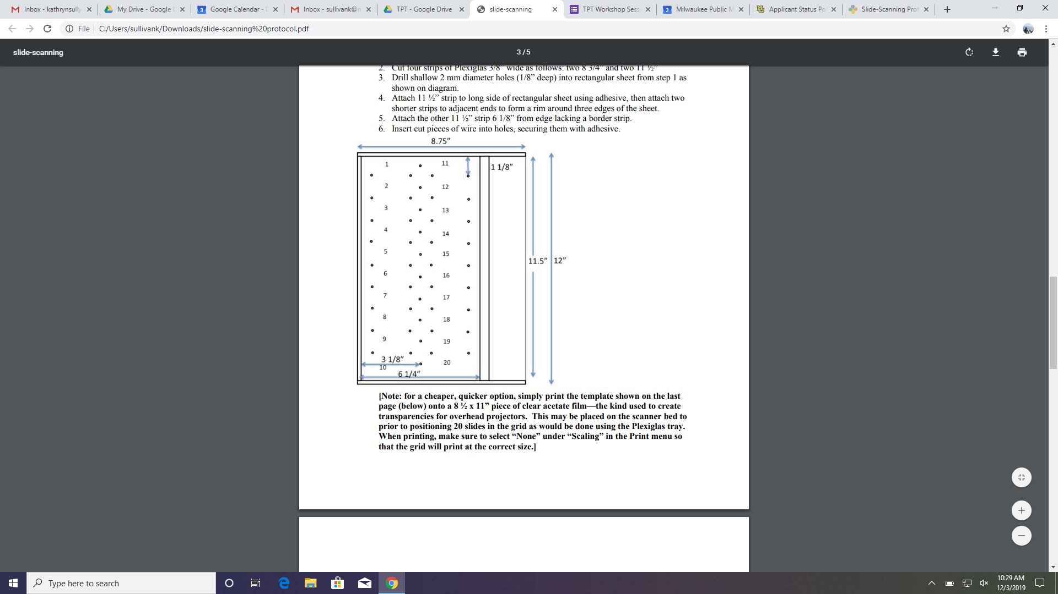

Vial scanning tray adjustments:

The vial scanning trays have the same dimensions as the slide scanning trays for slots 1-10 on the left side, comparable to the figure above. These spots are intended for blank microscope slides, which will hold the labels and unique identifiers from the corresponding vials in slots 11-20 directly across. These trays are designed to hold vials of varying sizes so slots 19 and 20 are not separated on the vial tray to accommodate larger vials. However two smaller vials could be placed in slot 19/20 with corresponding labels in slide slots 9 and 10.

Additional note:

Due to the variety in vial sizes, it may not always be possible to close the scanner lid over the tray so that it lays flat. Instead of closing the scanner lid you can place white paper in a tent over the tray so that it covers the top and sides to prevent excess reflection of light in the images.